Passive Houses Awareness and Economy
A comparison between Austria and Czech Republic

2009

Table of Contents
Table of Contents 0
1 Motivation 2
2 Passive Houses in Europe 3
2.1 Number of Passive Houses in Austria 3
2.2 Number of Passive Houses in the Czech Republic 3
3 Costs 3
3.1 Investment Costs in Austria 3
3.2 Investment Costs in the Czech Republic 4
3.3 Operating Costs in Austria 4
3.4 Operating Costs in the Czech Republic 4
3.5 NPV Calculation 4
4 How you get companies to build passive houses 5
4.1 Laws and Directives 5
4.1.1 Laws and Directives in Austria 6
4.1.2 Laws and Directives in the Czech Republic 6
4.2 Energy Performance Certificate 8
4.2.1 Energy Performance Certificate in Austria 8
4.2.2 Energy Performance Certificate in Czech Republic 8
4.3 Documentation and Information in Austria 9
4.4 Subsidies 10
4.4.1 Subsidies in Austria 10
4.4.2 Subsidies in Czech Republic 11
5 How do you make people buy passive houses 12
5.1 Results from the survey 12
5.2 Awareness 13
5.3 Education 14
6 Conclusion 15
7 References 16

Motivation
The set goals of the Kyoto protocol should be reached 2012. Austria’s goal to decrease the green house gas emissions by 13 percent, is a larger decrease than the European average, though this target is far from reached on the contrary the emissions have increased/9/. For the Czech Republic the target is 8 percent and is also not yet reached. The building sector stands for 40 percent of the total energy use in the world today /2/. Decreasing the energy demand of houses, particularly for heating, by building and renovating existing buildings into passive standard could help reach these goals. Furthermore building passive houses has a positive effect of the independence of the country, which has become more imperative, due to the rising energy prices and the previous gas crisis.
The aim of this thesis is to prove if the investment into passive houses is economically efficient and describe the current situation in both Czech Republic and Austria. One part of the thesis also describes the technical standards and exemplify the existing given governmental subsidies in the countries today and the results of them regarding to the number of passive houses. Suggesting some solutions of possible improvement are also added. A big problem today is the unawareness among the common people; the paper will describe what is done today to inform and influence the population and new solutions for the future. To find out the awareness and opinion of the people a survey has been done in both Austria and Czech Republic.

Passive Houses in Europe
In the end of 2008 there existed more than 15 000 passive houses in the world. The international goal of percentage new buildings with passive standard in 2010 was set up at the sustainable energy days 2004 to 2-10 percent /1 s. 19/. The European Union has funded projects as the CEPHEUS-project (Cost Efficient Passive Houses as European Standards) to increase the number and knowledge, whereas the goal is to standardize passive houses and in the near future comply it as the new building standard./10/

Number of Passive Houses in Austria
Austria is one of the most passive house dense countries and has the most passive houses per capita in the world. In the beginning of 2008 there were 2600 realized passive house projects in Austria, which were around 25 percent of the total number in the world and four percent of the new building volume in Austria /2/. Year 2010 the goal for new built houses with passive standard in Austria is 28 percent comparing with the international goal above. Austria has come far in the development and there are already some cities, municipalities and states that have passive houses as a mandatory standard for new buildings.

Number of Passive Houses in the Czech Republic
The total number of passive houses in the Czech Republic is in comparison with German speaking countries relatively low. The current number of finished, occupied houses is around 50. The amount of these houses is gradually increasing, though the passive houses makes out only 1 ‰ (one per mille) of new buildings. It also must be mentioned that this situation is changing thanks to the subsidy program Green Investment Scheme and related news about it. Another reason is lack of qualified engineers and architects, who have enough experiences with designing buildings in passive house standard, and also lack of certified companies.

Costs
The investment cost (including the construction cost and cost of the design and related documentation for getting the building permission and also documentation for realization) are probably the most important factor when selecting house types whereas the client is generally disregarding the lifecycle costs and the long term maintenance of value. It is stated in most publications that the investment cost for passive house needn´t to be necessarily higher than for a conventional house, as the level of investment costs primarily depends on the design, used materials and related technical building services /22/. But this design must be made individually for each client and could be used just for one house, which makes the cost of design more expensive.

Investment Costs in Austria
The high-class windows, the increased insulation measures, the decentralized heat recovery ventilation system and the airtight building shell are factors that increase the investment costs and thereby daunt the client. In the EU sponsored project CEPHEUS,10 buildings with passive house standard were built and finished in Austria during the late 90s. The additional investment costs in these buildings compared to the reference buildings were from 0 to 17 percent /4 s. 92/.
The construction cost for a passive house in Austria today is lying, independent on the house type around 100 €/m² net floor area higher than a standard house. The construction costs for a conventional single home house is for example 1300 €/ m² net floor area alternatively 1400 €/ m² net floor area for a passive house, hence 8 percent higher for a passive house. Thereby the windows stands for 9,6 %, the insulation measures for 6,8% and the ventilation system for 5,1% of the construction costs /5, 6 /. This is the average additional costs of the total costs for passive houses in Germany and Austria but differ of course depending on the design and building services /3 s. 280/.

Investment Costs in the Czech Republic
Because of relatively low number of built passive houses and averseness of most of their owners to notify the investment cost, it is difficult to determine the average construction costs for existing passive houses in the Czech Republic.
Verifying the construction costs for a standard type house is therefore easier, whereas the needed data is less unproblematic to get hold of. Also many people are choosing the standard type houses, because they get already finished projects which only needs small changes and the time needed for preparative work is also shorter than in case of individual design.
Average construction costs for passive type houses are approximately 5 835 CZK/m3 (217,56 €/m3) of building volume, while construction costs for standard house are 4 612 CZK/m3 (171,96 €/m3) of building volume, where VAT is not included. (Average construction costs for Ph were calculated from building volume and building price – data from construction companies, average construction cost for standard house were taken over from www.stavebnistandardy.cz). This means that the construction costs for a type passive house are approximately 20% higher than for a standard house.

Operating Costs in Austria
The additional charges for a passive house can easily be amortized through the lower operating costs. In the CEPHEUS projects, the operating cost reduction was between 44-83 percent in the Austrian buildings and the heat requirement was reduced to an average of 83 percent /4 ss. 43, 87/.
In the final report of the CEPHEUS project the payback time is also calculated, whereas in Austria it differs between an immediate payback and 102 years, though the average time is 21 years. The method may be considerably misleading given that the interest and inflation is not taken in consideration. /4 s. 93/

Operating Costs in the Czech Republic
All new standard houses in CZ have the energy consumption between 80 and 120 kWh/m2 per year, which means that the passive house has the potential to save up to 87% of energy consumption during the operation of the building.

Calculation of Net Present Value (NPV)
In this part we compare two type houses, one in the passive standard and one classic. Both of them have almost similar floor area and both of them are built from bricks, we choose them because both of them are suitable for families with two children.
 | Investment cost in CZK (€) | Energy consumption for heating (kWh/m2)
Passive house (NERO 2020) | 5 820 000 (217 002) | 14,85
Standard house (Zuzana 2) | 4 550 000 (169 650) | 95
Tab. 1 – Houses compared in NPV calculation /23,24/
Following data have been used for the calculation of NPV:
Heat price – 666 CZK/GJ (24,83€/GJ), the heat price has been set according to the indicative price set by Energy regulation office and price declared by the association of heat producers.
Average annual heat price increase – 3,8%, this increase is calculated according to the presumption that increase of prices of natural gas as the main heat source will be about 2% higher than inflation. But the price of natural gas makes just about 50% of final price of heat . The forecasted increase have been consulted with experts at Department of Economics and Humanities, Faculty of Electrical Engineering, CTU in Prague. /25/.
Average annual inflation – 2,5% ( long-term goal of ČNB)
Payback period of investment into passive house is in this case 22 years and NPV value is 76 238 CZK, which means that investing into passive house is economically efficient. Whole calculation is added in the attachment.

Sensitivity analysis
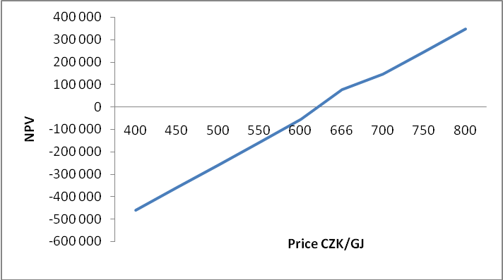
Picture 1 - Sensitivity analysis
The sensitivity analysis shows that in cases with heat price lower than calculated is NPV lower than 0 and therefore the investment wouldn´t be economically efficient.

How you get companies to build passive houses

Laws and Directives
The primer factor to get companies build more energy efficient houses are laws and directives. The energy efficiency in houses is regulated through the EU directive 2002/91/EC and the Energy Performance of Building Directive EPBD. In the EPBD the minimum standard for the European Union is stated.

Laws and Directives in Austria
The laws and regulations for buildings in Austria are controlled on a regional level in the nine federal provinces (Bundesländer), though the regulations from the EU and the OIB, Austrian Institute for Construction gives the comprehensive guidelines for the whole Austria. In the OIB Guideline 6 and supporting national standards the maximum annual heating demand per m2 of net floor area, the annual final energy consumption calculation, the maximum U-values of different elements of the building, the air tightness of the building, the prevention of thermal bridges and requirements on the quality of boiler, aeration systems and chillers as well as for new built buildings on systems for storage and distribution are stated.
The maximum annual heating demand according to the guidelines, depends on the geometric and are calculated as a function of the characteristically length but must not exceed a specified sum. These rules will be strengthened on the 1 January of 2010 from maximum 27 to 22,75 kWh/m2a on new non residential buildings, from 102 to 87,5 kWh/m2a for restoration of existing buildings and from maximum 78 to 66,5 kWh/ m2a for new residential buildings. The Bundesländer Burgenland and Vorarlberg have even gone further and have a requirement on 55 kWh/m2a for new residential buildings. In chapter 6 in the OIB Guidelines the U-value guideline of the different house components can be found, see figure below, and in chapter 8 of the OIB Guidelines the rules for the Energy Performance Certificate are described.
Tab. 2 - Required U-values on house components OIB Richtlinie 6 5.1
Component | U-Value [W/m²K]
Walls towards ambient air | 0,35
Walls and Floors towards the ground | 0,40
Windows towards ambient air | 1,4
Doors | 1,7
Roofwindow | 1,7
Roof towards ambient air | 0,2

    - Laws and Directives in the Czech Republic
The property developing companies are not interested in the energy efficiency of the building and its future operational cost; they want to gain as big profit as possible in the shortest period of time. That is probably the reason why there in CZ currently only exists one property developing company specialized on building low-energy and passive houses.
There are two possibilities how to make companies build houses in passive standard:
- to tighten up obligatory technical standards and allow them to build just the passive type of buildings
- to make them build passive due to increased demand for flats in passive houses
Tightening the technical standards isn´t probably the best solution and could be potentially problematic. Some problems can arise during the formulation of the standard (disagreements between members of the expert team and also with people with field experience etc.) but mainly it is the belief of architects and designers who have experiences with passive houses that environmental friendly solutions should not be forced on investors (future owner) /26/. This belief is also supported by the field data, which shows that the reduction in energy consumption is much higher in cases, where the owner wasn´t forced to choose the passive house but decided for the passive himself /26/.
A better way of making companies build passive houses is instead of concentrating on the supply side, focus on the demand side. By increasing the awareness of the investor (future owner) about the possible solution of reducing future operational cost with the design of the building and environmentally friendly solutions, the request for energy-efficient buildings will increase and the property developing companies has to follow the demand to profit.
ČSN 73 05 40 with its parts (1-Terminology, 2-Requirements, 3-Design values, 4-Calculation methods) is the most important technical standard which must be followed during the design of the building. Here are stated required values of critical thermal factor of internal surface, maximum U-value for different constructions, maximum decline of touch temperature and other values related to the internal temperature. Also recommended values of U-value and air-tightness of the building are included in this standard.
Required and recommended values of U for selected constructions:
Type of construction | U_{N,20} (W/m²K)
 | Required value | Recommended value
Roof (up to 45°) | 0,24 | 0,16
Wall (part of envelope)  Roof (45° and bigger) | 0,38 | 0,25
Windows and doors | 1,7 | 1,2
Roof windows | 1,5 | 1,1
Tab. 4 - Recommended U-values of constructions
Note: U-values should not exceed 2/3 of the recommended value for the design of low-energy building and should be much lower for the design of passive house.
Following table shows required and recommended U-values for the envelope of the building:
Recommended U-value | W/m²K) | 0,35
Required U-value | W/m²K) | 0,47
Average U-value of all buildings in CZ | W/m²K) | 1,07
Tab. 5 - Required and recommended U-values for the envelope of the building:
Reaching these values is obligatory for all new buildings (otherwise they should not get the building permission) and also for reconstructions of buildings if the calculation that it is doable, economical and would not harm the Environment.
The newly built standard family houses have a maximum energy consumption 142 kWh/m².a and blocks of flat must not reach consumption above 120 kWh/m².a.

Energy Performance Certificate
From 1st January 2009 it is compulsory for all new buildings and reconstructed buildings respectively renovated and public buildings larger than 1000 m2 to have an energy performance certificate. This is according to the EU directive 2002/91/EC, which was implemented latest 4th January 2006 in all member countries, as for Austria in law OIB RL 6 and in every Bundesland and for the Czech republic in law 406/2000 Sb /27/, The energy certificate consists of a protocol that proves the energy consumption of the building and the entire calculation of it and also a graphic presentation over the annual heating requirement in Austria and the total energy consumption in CZ where the building is placed on the scale A-G, whereas new buildings must reach level C. This certificate is necessary to have when selling and renting out a residential and non residential (e.g. offices) house and to be granted building permission. The validity of an energy performance certificate is 10 years.

Energy Performance Certificate in Austria
As already mentioned the different Bundesländer in Austria regulate the additional content and requirements in the EPC, although the calculations are stated in the OIB RL 6. The buildings are categorized in residential buildings and non residential buildings, where the non-residental buildings is subdivided in 12 different categories: Offices, kindergarten and schools, universities, hospitals, nursing homes, guesthouses, hotels, restaurants, venues, sport arenas and other conditioned buildings. For residential buildings the EPC comprises the annual heat demand which is compared with the reference-values in the graphic presentation, hot water demand, the total annual energy consumption, the mean U-value of the construction elements and recommended measures. The limits for annual heat demand and the graphic presentation on the energy performance certificate is shown below
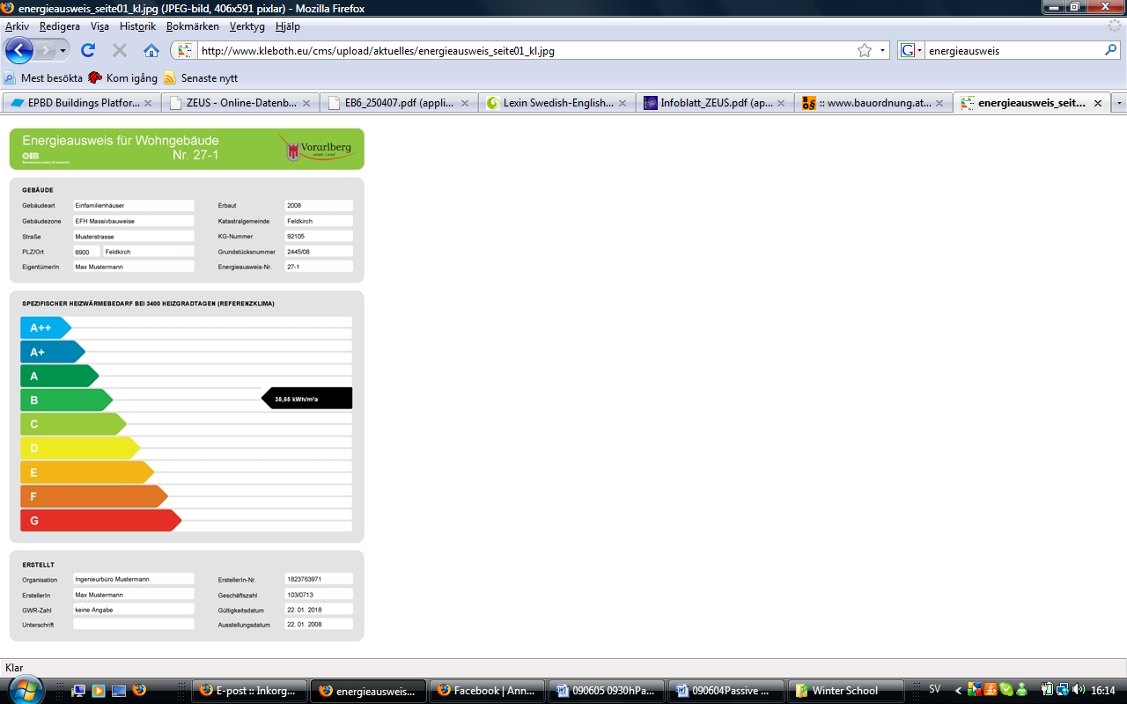
Klasse A++: HWB_{BGF,Ref} ≤ 10 kWh/m²a
Klasse A+: HWB_{BGF,Ref} ≤ 15 kWh/m²a
Klasse A: HWB_{BGF,Ref} ≤ 25 kWh/m²a
Klasse B: HWB_{BGF,Ref} ≤ 50 kWh/m²a
Klasse C: HWB_{BGF,Ref} ≤ 100 kWh/m²a
Klasse D: HWB_{BGF,Ref} ≤ 150 kWh/m²a
Klasse E: HWB_{BGF,Ref} ≤ 200 kWh/m²a
Klasse F: HWB_{BGF,Ref} ≤ 250 kWh/m²a
Klasse G: HWB_{BGF,Ref} > 250 kWh/m²a

Energy Performance Certificate in Czech Republic
The calculation of the EPC in the Czech Republic is done according to the national technical standards and public notice 146/2007 Sb. about energy intensity of buildings. Also the graphic presentation must be done in accordance with this public notice.
Buildings are separated into 7 categories - from A to G - and on the certificate is besides the category and consumption of energy shown also the category in which would the building belong after realization of recommended steps. The certificate shows specific calculated annual energy consumption in kWh/m2.year and total calculated annual supplied energy in GJ. Then it also shows proportion of supplied energy used for heating, cooling, ventilation, hot water preparation and for lighting in %.

Following table describes separation of building into categories according to energy consumption in kWh/m2.year:

Tab. 6 Energy performance certificate – building category (values in kWh/m2.year)
Type of building | A | B | C | D | E | F | G
Family house | ˂51 | 51-97 | 98-142 | 143-191 | 192-240 | 241-286 | ˃286
Block of flats | ˂43 | 43-82 | 83-120 | 121-162 | 163-205 | 206-245 | ˃245
Hotel and restaurant | ˂102 | 102-200 | 201-294 | 295-389 | 390-488 | 489-590 | ˃590
Administrative | ˂ 62 | 62-123 | 124-179 | 180-236 | 237-293 | 294-345 | ˃345
Hospital | ˂109 | 109-210 | 211-310 | 311-415 | 416-520 | 521-625 | ˃625
School | ˂47 | 47-89 | 90-130 | 131-174 | 175-220 | 221-265 | ˃265
Sport | ˂53 | 53-102 | 103-145 | 146-194 | 195-245 | 246-297 | ˃297
Shopping | ˂67 | 67-121 | 122-183 | 184-241 | 242-300 | 301-362 | ˃362

A - extremely economic
B - economic
C - convenient
D - inconvenient
E - uneconomic
F - very uneconomic
G - extremely uneconomic

All new buildings must reach at least C category.

Documentation and Information in Austria
The documentation in the different states in Austria is extensive through the regional authorities, energy associations and energy institutes, but different structures in the databases have made it difficult to gather everything in one database.
The cooperation project IGPassivhaus was iniated by the Federal Ministry of Transport, Innovation and Technology to inform and accelerate the proceeding for passive houses to become the future construction standard. The project were with their publically accessibility established to increase the knowledge and awareness of passive houses through giving information about already built houses and share the experiences from the owners. It was also established to decrease the prejudices which exist about passive houses. All the information from all nine Bundesländer is gathered at the homepage www.igpassivhaus.at. The report “1000 passive houses in Austria” where already built houses are documented plays a big part .Totally there are 200 member firms and a close cooperation between the companies and the experts has made it easy to secure the quality controls. The homepage is still under construction but is a good platform for planers, property developer, trade and the common people to find information about passive house standard, building types, use, construction, building services and architectural solutions plus already built examples. /1 s. 93/

Subsidies
Although in the future a higher energy price and the independence will be the biggest incentive for building passive houses, the situation today shows that the most efficient way is to introduce subsidies.

Subsidies in Austria
Due to the different funding given in the different Bundesländer in Austria the effects of them become clear also within the country. See picture 2 below.
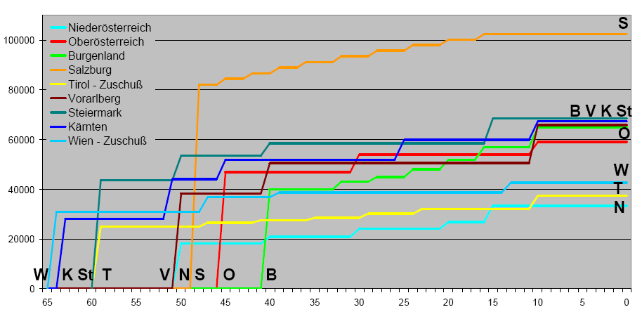
X- axis: Annual heat requirement, y-axis: Funding in Euro
Picture 2 - Funding consisting of reimbursable loan depending on energy efficiency of the buildings. In Vienna and Tyrol the funding is a subsidy.

In the following the market development and the subsidies of low energy buildings (50 kWh/m²a space heating demand and passive houses with 15 kWh/m²a) are discussed.
In 2001 the enhancement of the directive on house construction subsidy was shown in the state Upper Austria. In Tirol a funding of 9040 Euros more is granted for a passive house (<15 kWh/m2a) instead of a low energy house.
The increase of passive houses in state Lower Austria in 2003 also depended on an improved amendment where the passive house project received 30 percent more subsidy than a low energy house. The result of this was an increased funding from 0,4 to 10 percent with a funding of 37 000 Euro of reimbursable loans.
Due to the additional demands which were made in the Ecological standard, the positive trend in Vorarlberg and Upper Austria stagnated 2005. In Vorarlberg, passive houses with a heat demand less than 10 kWh/m2a get 22100 Euro in reimbursable loans.
In Vienna apart from the competitions that has been given the interest from the developing companies to build passive has been low. An amendment in 2004 increased the passive house project slightly. Today the direct funding is 11 500 Euro more than a low energy house. With a heat demand less than 12,75 kWh/m2a instead of 50 kWh/m2a.
In Bundesland Carinthia the development of passive houses started quite late, but due to the direct subsidy for the first 50 houses of a non-repayable grant of 7500 Euro for single family houses and 15000 Euro for multi-family houses that was introduced 2006 a passive house boom has been created the last years. The houses with a heat demand less than 15kWh/m2a is also granted 19000 in reimbursable loans. In state Styria the funding is 15000 Euro in reimbursable loans more than for a low energy house.
The funding, subsidies and loans, in Vienna, Styria, Carinthia, Lower Austria, Tirol and Vorarlberg cover in these states the average 5-8 percent additional charges of a passive house. This means that the owner of a passive house in these states will have a better start with their repayments of the investment costs with the earned money from the decreased energy utilization from day 1 compared to a low energy house. Due to the lack of funding of passive house standard in state Burgenland, they were the last state to build passive houses and in state Salzburg though an early start the lack of funding for more energy efficient houses and interest have hold the numbers of passive houses down. This is clearer shown in the graph with the comparison of funding differences to a Low-energy house with 50 kWh/m2a and the amount new built passive houses.
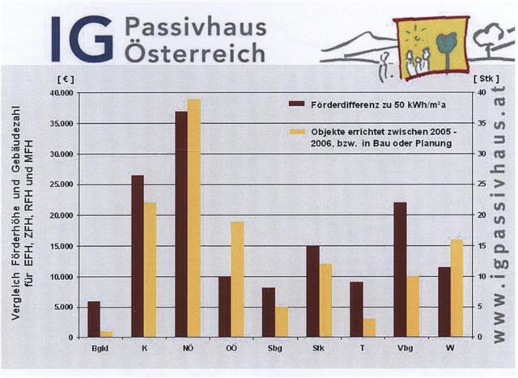
Picture 3 -Comparison of funding differences from a Lowenergy house and passive houses and number of passive houses in the different Bundesländer.

Subsidies in Czech Republic
The first program in the Czech Republic, which includes financial support for passive houses themselves, was started but this year although the neighbor countries such as Germany and Austria have analogous programs longer time. This program is called Green investment scheme and the money which are used for subsidies Czech Republic gained from International Emission Trading according to the Kyoto protocol.
Previous support programs include subsidies for improving insulation ability of envelope of the building and for use of renewable resources for heating.
Support for buildings in passive house standard is included in part B.1 of this program (Support of new buildings in passive house standard). This part includes new buildings and also reconstructed buildings designed for living, which reach the passive house standard. The main criterion for getting the subsidy is the average consumption of energy for heating below 20 kWh/m2.a for family houses and 15 kWh/m2.a for blocks of flats. These houses must fulfill also other criteria, such as efficiency of recuperation, maximum air temperature in rooms, primary energy consumption and airtightness of building. The fulfillment of all criteria mentioned above must be proved by calculation according to ČSN EN ISO 13790 and related technical standards and this calculation must be done by chartered engineers, architects or energy auditors.
Besides the technical criteria that the designed building must fulfill, there are other requirements related to the construction works, which must be realized. Houses must be built only from certified materials, which are listed in the register managed by the ministry. Also the construction works must be done by certified companies, which are also listed in the ministry register.
The subsidy is granted only to first owner of the house or flat built in passive house standard and the amount of money they can get is fixed: 220 000 CZK for family house, 140 000 CZK for flat.
Program Green investment scheme lasts from 1st April 2009 to 31st December 2012 and people can apply for subsidies during whole period. The application is send before starting of construction works and the subsidy is send after proving that the house is finished.
The supposed amount of new buildings in passive house standard built thanks to the subsidy scheme is 4900 family houses and 8700 flats. The supposed number of flats in passive house is debatable, because the financial support goes to the first owner not to the developer. This means that the companies, which are designing, constructing and then selling flats, are not motivated to build blocks of flats in passive house standard.

How do you make people buy passive houses

Results from the survey
The survey about the knowledge of the common people was given to 20 respectively 24 people in CZ and Austria between the ages of 18-80 years old with different kinds of education level. Due to the small amount of participants, the results should only give a basic view of the knowledge and mainly the differences between the countries.
Accordingly to the survey almost everyone, 90 percent, knew what a passive house was in Austria although surprisingly there was a higher percentage in the Czech Republic. Though it must be mentioned that although 95 percent of the respondents wrote that they knew what a passive and low energy house was in CZ, we believe that some of them only have a vague idea what it is and some just didn´t want to write that they don´t know anything about them. Most people in Austria know about the passive houses from newspaper (57%) or TV (19%) and studies (14%). In CZ it is more equally divided, mainly from TV, studies or web but the differences are very small among all values (14-25%)
A big difference between the countries is how many have visited a passive house, only 20 percent of the respondents in the Czech Republic compared with almost 60 percent in Austria. Evidently the higher number of passive houses in Austria affects this percentage. An interesting comparison is the higher percentage who has been in a passive house (57%) compared to knowing an owner of one (47%) in Austria whereas in the CZ the difference was 5 percent. This can exemplify the effort that is made in Austria to inform and increase the knowledge by having excursions and open house in new passive houses.
Only 50 percent of the respondents knew what an energy performance certificate was and about 55 percent knew what it was in the Czech Republic, though these were mainly people with civil engineering education.
When it comes to the economy 63 percent of the respondent would be prepared to pay a 10 percent or higher investment cost for a passive house, although only 18 percent are prepared to have a 20 percent or higher investment cost. The causes why people would want to buy a passive house are mostly because of the ecology and the efficiency of the heating.
The question about the required subsidy to make a decision to buy a passive house over 80 percent in Austria answered that 20 percent is enough and even over 50 percent said that 10 percent would be enough funding. In Czech Republic 55 percent of the respondents would choose a passive house with a funding of 20 percent of the investment cost and 35 percent said that 10 percent would be enough. But compared with Austria there are no one answered only 5 percent subsidy is acceptable for making a decision. Although these are extraordinary numbers it also shows the unawareness of how much more a passive house would really cost though the average as mentioned before is 8 percent of the investment cost. It is more likely to accept a higher cost in a survey than in real life.
From the factors that have the main influence on the decision of buying a passive house the ecology and the economy of heating are most important in Austria. These two make 85 percent of the preferences. In Czech Republic it is again more equable 30 percent have funding and payback time on 10 years, than 25 percent ecology and only 15 percent has the economic factor.
Finally we asked about the feature preferences of the passive houses. We offered the options: age of the construction, house lay-out, lifetime of the construction, design, inside microclimate, investment cost, time of the construction and location.
In Austria the main factor when choosing a house is the lifetime of the construction, house lay-out and the inside microclimate, afterwards comes quality and age of the construction. The operational or investment cost and the location are not among the most important features. In Czech Republic is the result a little different. Lay-out, quality of the construction and the design are among the most preffered features, then lifetime and time of the construction are also important. Investment and operational cost belong again among the features with less preference together with inside microclimate.

Awareness
There are many reasons why passive houses are so rare, but an important factor is the lack of information among the common people. The information concerning passive houses can easily be found in internet and in specialized books or magazines (esp- technical), but people must actively take initiative. What is missing today especially in the Czech Republic is the open discussion in media, especially in television and also an information and advertising campaign which would assist to spread this information among as many people as possible.
Not many people know how many kWh/m2a they consume through heating, hot water and electricity. The energy performance certificate is here a big asset when deciding of buying a house. Through the unpretentious scale for the annual heating demand the common people can get an overview and compare houses with each other without having a deeper knowledge about energy consumption. The energy performance certificate increases therefore the economical worth of a passive standard house and can therefore equalize to some extent higher investment costs. Although the knowledge of the energy certificate performance is according to our survey not that high, while it is relatively new and will increase in the near future.
Though the doubts about passive houses still exist, the statistic shows that employees in a passive standard building have less sickdays per person then in a standard building and that the business climate and concentration improves (1). The satisfaction of the present passive house owners are high and along the people that are less satisfied are the ones that did not have knowledge about passive houses before and have not gotten enough information. For a passive house to be used correctly the owners must be conscious of their influence on the energy consumption and comfortableness in the house. The decreasing of comfortableness in the summer for passive houses can for example be justified by falsely use of the solar protection. For that reason the owners should be offered a detailed introduction of the use of their passive house. A meter for the energy consumption is also to be recommended (6). Today are EU and government funding development projects as the ZigBee and the ELAN program in Sweden where the electricity, hot water and also CO2-emission can be measured and displayed for an individual house. A project in Sweden where displays showing the hot water consumption in the apartment showed a decreased usage of 50 %.

Education
Information is a strong weapon, through the homepages www.hausderzukunft.at, www.igpassivhaus.at and www.passivehouses.at in Austria you can actively search for information and help. But it is also important to give information passively through media and education. Statistics shows that the children in Germany that learned about energy efficiency in school are more active and interested in the subject.
Also as mentioned before the owners who did not actively choose to live in a passive house consume more energy and the most owners that chose to build a passive house has already experience it in real life. People are afraid of what they don´t know and prefers to stick with what they do know.

Conclusion
The NPV calculation for the selected houses proved that investing in a passive house is economically effective in the long run. Although the extra investment (higher investment costs for passive) easily can be amortized by the saving from lower operating costs are these houses rare especially in the Czech Republic. Although the same result has been shown in Austria with the same payback time the situation is totally different whereas Austria is the leading countries in number of passive houses. These differences are probably caused by the long and generous subsidy program in Austria and also a higher environmental knowledge of the Austrians. The awareness among the common people has probably also affected of these projects, whereby they also have been noticed in media.
To give subsidies for passive houses are not a sustainable solution all the same it has had a big effect on introducing passive houses on the market. When passive houses have become more standardized and common, the subsidies, as shown in our survey knowledge about passive houses reduces the energy consumption and increases the demand of them. The introduction of subsidies for Czech Republic which still has few passive houses is a good idea.
As already mentioned earlier the knowledge of the common people comes with the amount of passive houses in the country, but to quicken this procedure with accessible documentation, information and possibilities to visit passive houses as the project IG Passivhaus in Austria, is a good example for spreading the awareness.
For people to see and thereby passively acknowledge their consumption is probably the most important matter, with the introduction of the energy performance certificate and displays showing hot water and energy spending the common people can also relate and understand the consequences of the houses contexture and their own actions which will be the main factor of the success of the passive houses.

References

1. Lang, G. 1000 Passivhäuser in Österreich. Wien : Bunderministerium für Verkehr, Innovation und Technologie, 2006.
2. IG Passivhaus. [Online] 04 2009. www.igpassivhaus.at.
3. Feist, W. CEPHEUS Final Technical Report. Hanover : s.n., 2001.
4. Lang, G. Passivhausförderung in Österreich. Ökonews. 27/6, 2006.
5. Institut für Landes- und Stadtentwicklungsforschung und Bauwesen des Landes Nordrhein-Westfalen. Leben im Passivhaus. Aachen : ILS-NRW-Schriften Bd. 202, 2007.
6. Sommer, A-W. Passivhäuser, Planung- Konstruktion- Details- Beispiele. Köln : Verlagsgesellschaft Rudolf Müller GmbH & Co, 2008.
7. Bautechnik, Österreichische Institut für. www.oib.or.at. OIB Richtlinie 6. [Online] 04 2007. www.oib.or.at.
8. Grobe, C. Passivhäuser- planen und bauen. Bolzano : Fotolito Longo, 2002.
9. EURIMA. [Online] 06 2009. www.eurima.org
10. CEPHEUS. [Online] 06 2009. www.cepheus.de
14. Cenové ukazatele ve stavebnictví. www.stavebnistandardy.cz. [Online] (Price indicators in civil engineering)
15. ČSN 730540-2: Tepelná ochrana budov - část 2: požadavky. (Technical standard for building design)
16. Green architecture.cz. collective of authors.
17. Chalenge Europe. http://chalengeeurope.britishcouncil.org; www.setrne budovy.cz.
18. Ministry of the Environment of the Czech Republic. www.mzp.cz; www.sfzp.cz. [Online]
19. The centre for passive house. www.pasivnidomy.cz. [Online]
20. vyhláška č. 147/2007 Sb. o energetické náročnosti budov. (Public notice – energy intensity of buildings
21. Tywoniak, J. Nízkoenergetické domy 2: principy a příklady. (Low-energy houses: Principles and examples)
22. Srdečný, K., Jak postavit nízkoenergetický dům, Ekowatt 2008 (How to build an low-energy house)
23. Agentura NÁŠ DŮM, Nízkoenergetické domy /2/ - katalog (Catalogue of designs)
24. Ekonomické stavby, www.ekonomicke-stavby.cz (Catalogue of designs)
25. Energetický regulační úřad, www.eru.cz (Energy regulation office)
26. Brotánek, A., Důležitost zvládnutí lidského faktoru pro environmentálně šetrný život budovy. (The importance of human factor management for environmentally friendly life of building)
27. zákon č. 406/2000 Sb. o hospodaření s energií ve znění pozdějších předpisů (Energy conservation law)
Table 1. Houses compared in NPV calculation
Table 2. Required U-values on house components OIB Richtlinie 6 chapter 5.1
Österreichische Institut für Bautechnik. www.oib.or.at. OIB Richtlinie 6. [Online] 04 2007. www.oib.or.at. page.6

Table 3. Recommended U-values of construction in CZ
Table 4. Required and recommended U-values for the envelope of the building
Table 5. Energy Performance Certificate- Buildings Categories
Picture 1. Sensitivity analysis
Picture 2. Funding depending on energy efficiency of the buildings. www.igpassivhaus.at
Picture 3 Differences in funding and built passive houses in different Bundesländer.
, G. 1000 Passivhäuser in Österreich. Wien : Bunderministerium für Verkehr, Innovation und Technologie, 2006. Page 107.
Attachment

Calculation of NPV

Dům NERO 2020 |  |  |  | Zuzana 2
Heat requirements | 14,88 | kWh/m2 |  | 95 | kWh/m2
Lay-out | 5+kk |  |  | 6+1
Built-up area | 147,07 | m2 |  | 130
Volume of building | 997 | m3
Floor area (m2) | 208,79 | m2 |  | 211,2
Price (Kč) | 5 820 000,00 |  |  | 4 550 000,00
Price for GJ (Kč) | 666
Operational cost - heating (Kč) | 7 448,85 |  |  | 48 105,45

 | 1 | 2 | 3 | 4 | 5 | 6
CF | -1 270 000,00 | 40 657 | 42 202 | 43 805 | 45 470 | 47 198
kCF | -1 270 000,00 | -1 229 343 | -1 187 142 | -1 143 337 | -1 097 867 | -1 050 669
dCF | -1 270 000,00 | 38 698 | 39 188 | 39 685 | 40 189 | 40 698
kdCF | -1 270 000,00 | -1 231 302 | -1 192 114 | -1 152 429 | -1 112 240 | -1 071 542

 | 7 | 8 | 9 | 10 | 11 | 12 | 13 | 14
CF | 48 991 | 50 853 | 52 785 | 54 791 | 56 873 | 59 034 | 61 278 | 63 606
kCF | -1 001 678 | -950 825 | -898 040 | -843 249 | -786 376 | -727 341 | -666 064 | -602 458
dCF | 41 215 | 41 737 | 42 267 | 42 803 | 43 346 | 43 895 | 44 452 | 45 016
kdCF | -1 030 327 | -988 590 | -946 323 | -903 521 | -860 175 | -816 280 | -771 828 | -726 812

 | 15 | 16 | 17 | 18 | 19 | 20 | 21 | 22
CF | 66 023 | 68 532 | 71 136 | 73 839 | 76 645 | 79 558 | 82 581 | 85 719
kCF | -536 434 | -467 902 | -396 766 | -322 927 | -246 281 | -166 723 | -84 142 | 1 577
dCF | 45 587 | 46 165 | 46 750 | 47 343 | 47 944 | 48 552 | 49 168 | 49 791
kdCF | -681 225 | -635 060 | -588 310 | -540 966 | -493 023 | -444 471 | -395 303 | -345 512

 | 23 | 24 | 25 | 26 | 27 | 28 | 29 | 30
CF | 88 977 | 92 358 | 95 867 | 99 510 | 103 292 | 107 217 | 111 291 | 115 520
kCF | 90 554 | 182 911 | 278 778 | 378 289 | 481 580 | 588 797 | 700 088 | 815 608
dCF | 50 423 | 51 062 | 51 710 | 52 366 | 53 030 | 53 702 | 54 384 | 55 073
kdCF | -295 089 | -244 027 | -192 317 | -139 951 | -86 921 | -33 219 | 21 165 | 76 238

kCF – cumulated cashflow
dCF – discounted cashflow
kdCF – cumulated discounted cashflow

